Le Project du Semestre
(Semester Projects)

The areas where French is spoken are many and varied in terms of people (lives, values, customs, etc.), and things (objects of art, pieces of literature, history, etc.). These make up the culture of an area.

It is important to learn about different cultures in order to appreciate them and to improve relations between “us” and “them”. Your efforts to increase your knowledge about French culture don’t have to and should not take place in the classroom. There is much to explore outside the classroom.

You will be completing TWO semester projects (one per 18 wks) this year. Since students have different interests, learning styles, and talents, the project options are quite varied. The attached page offers some project ideas. You must see the teacher to have your project approved and discuss the requirements.

Don’t assume anything! Follow directions given! See the teacher if your selected project option instructs you to do so and/or if you have any questions. We do not spend any class time on these projects so please plan accordingly!

* This is an excellent opportunity to take your language learning above and beyond classroom expectations.

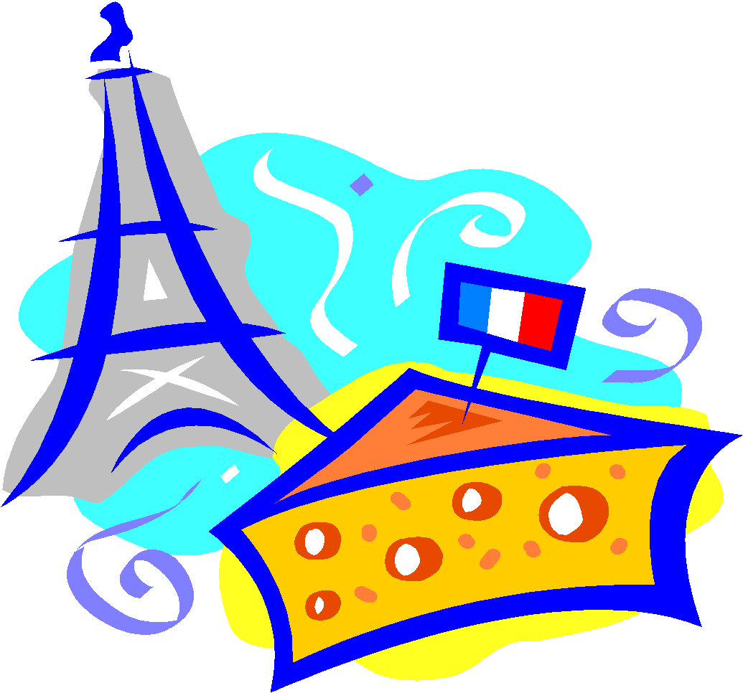
Projects are accepted on (or before if needed) the due date but not after! You may work ahead if you have the opportunity to do so.

Project Ideas

- French Recipe
- Must be an authentic French recipe
- How you made it
- Recipe card; en français
- Why you chose this particular recipe
- Signed form that you made it

- Musical Piece
  - Must choose a piece by a French or Francophone composer or
  - A musical piece that has an important role in one of these countries cultures
  - Why you chose it
  - You can sing, or play a musical instrument

- Drawing/Painting/Sketch i.e. Work of Art
  - What you drew/painted
  - Why
  - If you’re duplicating an artist’s work you must tell me the original artist
  - If you’re duplicating something, include a copy of what you’re copying
  - Explain your work of art to the class

- Map
- Choose a Francophone city
- Map it out on a poster board
- Label 20 different tourist sites or monuments within the city
- It cannot be Paris!!!

- Poster
- Must be a poster of vocabulary or grammar
- If you choose vocabulary, the words must fit under a category
  - i.e. Fruit: and you’d have pictures and words of various fruits
- Must be a minimum of 20 vocabulary words
- See me for approval on what your poster design and content will be
- Explain to the class what your poster is and why you chose it
- Must go above & BEYOND in effort & construction

- Translation Page
  - See me for approval on what you’d like to translate.
  - Must translate from French into English
  - Must be at least one page of French
  - Must show work
  - Must reflect on the meaning of the page and what you learned about it

- Other- See Mme if you are interested in doing a project other than the above choices

